23-09-2021

ABHINAV RANJAN

RA1911003010003

CSE A1 SECTION

SRMIST KTR

CN LAB - ARP SIMULATION

CODE :

1.SERVER

#include <sys/types.h>

#include <sys/socket.h>

#include <stdio.h>

#include <stdlib.h>

#include <netdb.h>

#include <netinet/in.h>

#include <string.h>

#include <sys/stat.h>

#include <arpa/inet.h>

#include <unistd.h>

#define MAX 1000

int main()

{

int serverDescriptor = socket(AF_INET, SOCK_DGRAM, 0);

int size;

char buffer[MAX], message[] = "Command Successfully executed !";

struct sockaddr_in clientAddress, serverAddress;

socklen_t clientLength = sizeof(clientAddress);

bzero(&serverAddress, sizeof(serverAddress));

serverAddress.sin_family = AF_INET;

serverAddress.sin_addr.s_addr = htonl(INADDR_ANY);

serverAddress.sin_port = htons(9976);

bind(serverDescriptor, (struct sockaddr *)&serverAddress, sizeof(serverAddress));

while (1)

{

bzero(buffer, sizeof(buffer));

recvfrom(serverDescriptor, buffer, sizeof(buffer), 0, (struct sockaddr *)&clientAddress, &clientLength);

system(buffer);

printf("Command Executed ... %s ", buffer);

sendto(serverDescriptor, message, sizeof(message), 0, (struct sockaddr *)&clientAddress, clientLength);

}

close(serverDescriptor);

return 0;

}

2. CLIENT

#include <sys/types.h>

#include <sys/socket.h>

#include <stdio.h>

#include <unistd.h>

#include <netdb.h>

#include <netinet/in.h>

#include <string.h>

#include <arpa/inet.h>

#define MAX 1000

int main()

{

int serverDescriptor = socket(AF_INET, SOCK_DGRAM, 0);

char buffer[MAX], message[MAX];

struct sockaddr_in cliaddr, serverAddress;

socklen_t serverLength = sizeof(serverAddress);

bzero(&serverAddress, sizeof(serverAddress));

serverAddress.sin_family = AF_INET;

serverAddress.sin_addr.s_addr = inet_addr("127.0.0.1");

serverAddress.sin_port = htons(9976);

bind(serverDescriptor, (struct sockaddr *)&serverAddress, sizeof(serverAddress));

while (1)

{

printf("\nCOMMAND FOR EXECUTION ... ");

fgets(buffer, sizeof(buffer), stdin);

sendto(serverDescriptor, buffer, sizeof(buffer), 0, (struct sockaddr *)&serverAddress, serverLength);

printf("\nData Sent !");

recvfrom(serverDescriptor, message, sizeof(message), 0, (struct sockaddr *)&serverAddress, &serverLength);

printf("UDP SERVER : %s", message);

}

return 0;

}

SCREENSHOTS :

1. SERVER SIDE

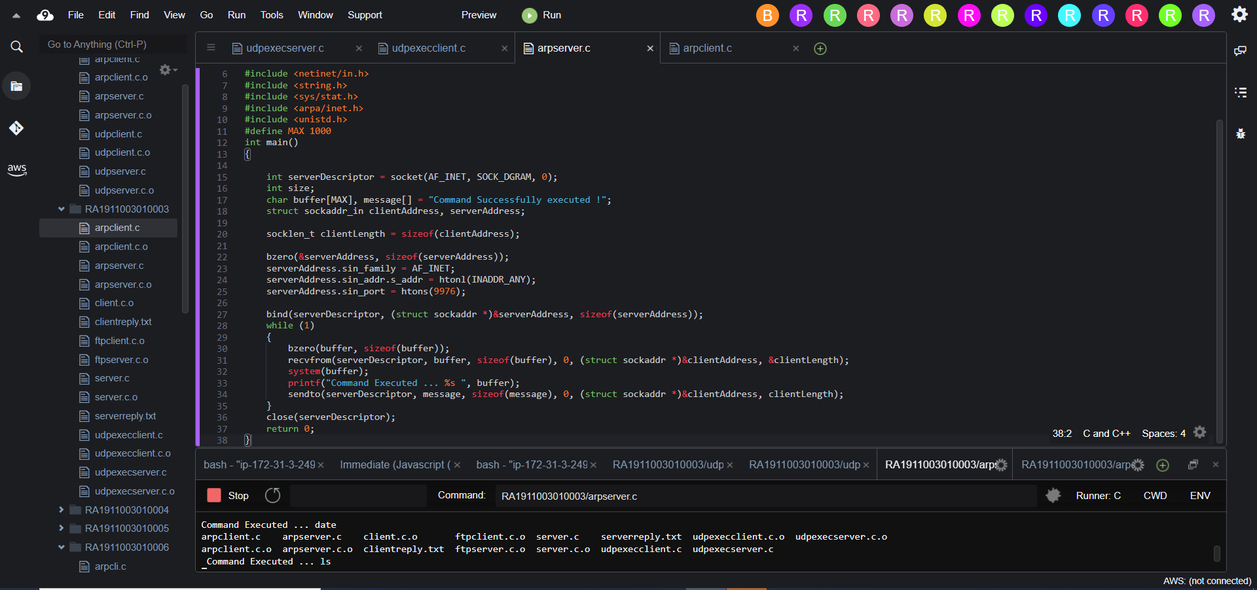

1. CLIENT SIDE

